Step 1: Install Necessary Dependencies (for mechanism network research)
Install Python:
!pip install pandas numpy requests networkx gseapy
Step 2:
Run Python:
from google.colab import files
uploaded = files.upload() # A browser pop-up will appear; select the locally downloaded GSE33000.top.table.tsv
Step 3:
Run Python:
from google.colab import files
uploaded = files.upload() # A browser pop-up will appear; select the locally downloaded GSE44770.top.table.tsv
Step 4:
Run Python:
!ls -l
Expected output similar to the figure:
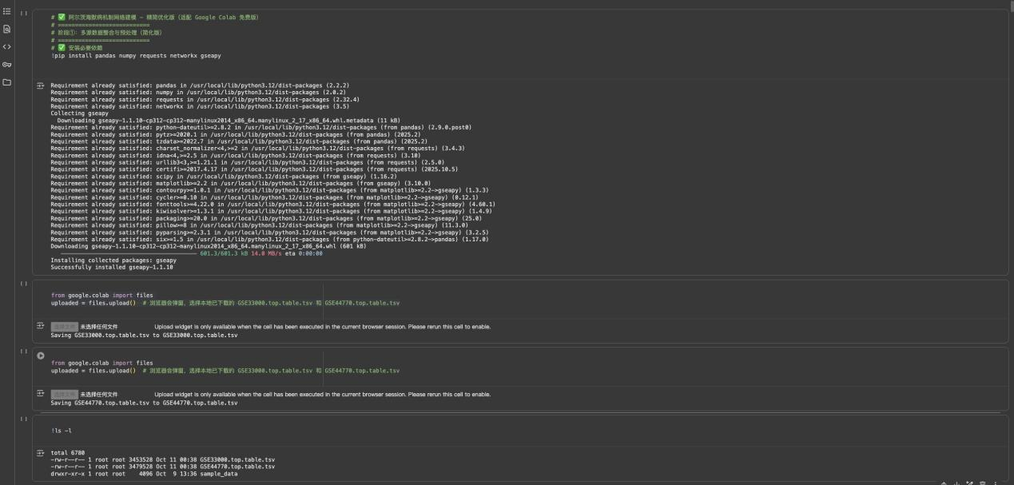
Step 5:
Run Python: AD-Chapter 1-01.txt
Step 6:
Run Python:
from google.colab import files
uploaded = files.upload()
Expected output similar to the figure:
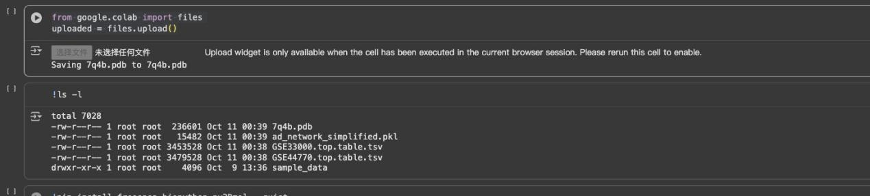
Step 7:
Run Python:
!ls -l
Step 8:
Run Python: AD-Chapter 1-02.txt
Step 9:
Run Python: AD-Chapter 1-03.txt
Step 10:
Run Python: AD-Chapter 1-04.txt
Step 11:
Run Python: AD-Chapter 1-05.txt
Step 12:
Run Python: AD-Chapter 1-06.txt
Step 13:
Run Python: AD-Chapter 1-07.txt
Step 14:
Run Python: AD-Chapter 1-08.txt
Step 15:
Run Python: AD-Chapter 1-09.txt
Step 16:
Run Python: AD-Chapter 1-10.txt
Step 17:
Run Python: AD-Chapter 1-11.txt
Step 18:
Run Python: AD-Chapter 1-12.txt
Step 19:
Run Python: AD - Chapter 1 - Virtual Patient Analysis of the Non-PJ Hypothesis
Step 20:
Run Python: AD - Chapter 1 - Virtual Patient Analysis of the PJ Hypothesis
Step 21:
Run Python: AD-Chapter 2 - Drug Design01
Step 22:
Run Python: AD-Chapter 2 - Drug Design02
Step 23:
Run Python: AD-Chapter 2 - Drug Design03
Step 24:
Run Python: AD-Chapter 2 - Drug Design04
Step 25:
Run Python: AD-Chapter 2 - Drug Design05
Step 26:
Run Python: AD-Chapter 2 - Drug Design06-1
Step 27:
Run Python: AD-Chapter 2 - Drug Design06-2
Step 28:
Run Python: AD - Chapter 2 - Virtual Cell Based on Linear Theory
Step 29:
Run Python: AD-Chapter 2 - PJ Virtual Cell-1
Step 30:
Run Python: AD-Chapter 2 - PJ Virtual Cell-2
Step 31:
Run Python: AD-Chapter 2 - PJ Virtual Cell-3
Step 32:
Run Python: AD-Chapter 2 - PJ Virtual Cell-3Chart
Step 33:
Run Python: AD - Chapter 2 - Virtual Patient of Linear Theory
Step 34:
Run Python: AD-Chapter 2 - PJ Virtual Patient-1
Step 35:
Run Python: AD-Chapter 2 - PJ Virtual Patient-2
Step 36:
Run Python: AD-Chapter 2 - PJ Virtual Patient-3
Step 37:
Run Python: AD-Chapter 2 - PJ Virtual Patient-4
Step 38:
Run Python: AD-Chapter 2 - PJ Virtual Patient-5

Step 39:
Run Python:
# 第一步：挂载Google Drive（每次重启Colab都需先执行这步）
from google.colab import drive
drive.mount('/content/drive') # 执行后点击链接授权，粘贴授权码完成挂载

# 第二步：创建数据集保存目录（在Drive中新建文件夹，避免文件混乱）
# 这里将数据集保存在 Drive 的 "RNA_seq_Datasets" 文件夹中，可自行修改文件夹名
import os
# 定义保存路径（/content/drive/MyDrive/是Drive根目录，后面跟你想创建的文件夹名）
save_folder = '/content/drive/MyDrive/RNA_seq_Datasets'
# 若文件夹不存在则自动创建
if not os.path.exists(save_folder):
os.makedirs(save_folder)
print(f"数据集将保存到：{save_folder}")

# 第三步：上传本地数据集（GSE33000 和 GSE44770）
from google.colab import files
import shutil

# 上传第一个数据集：GSE33000_raw_data.txt
print("="*50)
print("请上传第一个数据集：GSE33000_raw_data.txt")
uploaded1 = files.upload() # 点击弹窗选择本地的GSE33000文件
# 将上传的文件移动到Drive的保存目录
for filename in uploaded1.keys():
src_path = filename # Colab临时上传路径
dst_path = os.path.join(save_folder, filename) # Drive目标路径
shutil.move(src_path, dst_path)
print(f"✅ GSE33000_raw_data.txt 已保存到：{dst_path}")

# 上传第二个数据集：GSE44770_originaIDataFile_PFC.txt
print("\n" + "="*50)
print("请上传第二个数据集：GSE44770_originaIDataFile_PFC.txt")
uploaded2 = files.upload() # 点击弹窗选择本地的GSE44770文件
# 将上传的文件移动到Drive的保存目录
for filename in uploaded2.keys():
src_path = filename
dst_path = os.path.join(save_folder, filename)
shutil.move(src_path, dst_path)
print(f"✅ GSE44770_originaIDataFile_PFC.txt 已保存到：{dst_path}")

# 第四步：验证文件是否成功保存（可选，用于确认）
print("\n" + "="*50)
print("Drive保存目录中的文件列表：")
!ls -l {save_folder} # 列出目录下的文件，确认两个数据集都在
Expected output similar to the figure:
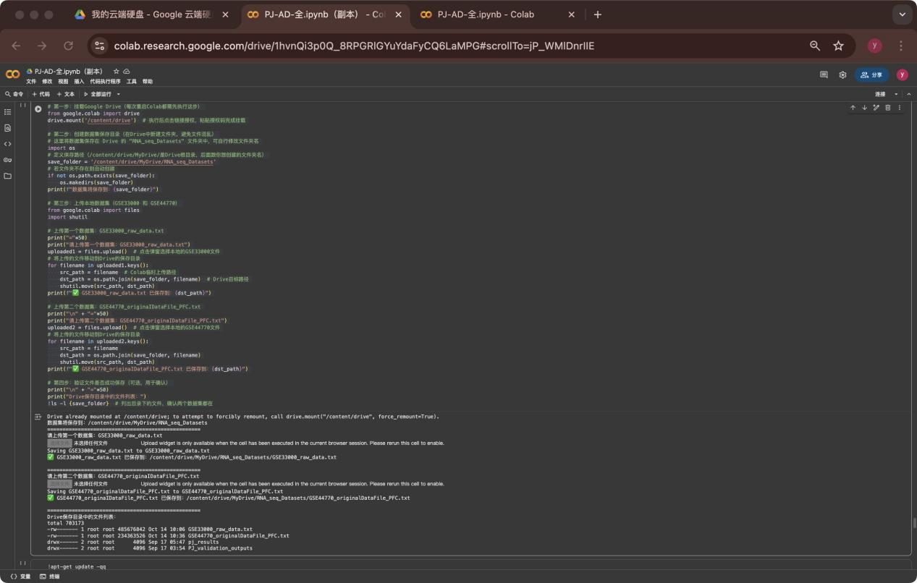
Step 40:
Run Python: AD - Chapter 3 - PJ Hypothesis Validation-01
Step 41:
Run Python: AD - Chapter 3 - PJ Hypothesis Validation-02
Note:
All the code above is located in the code folder on GitHub.
For the database download method in Step 33, see details in GSE33000TXT, GSE44770TXT, and Download.word in the GitHub repository.

